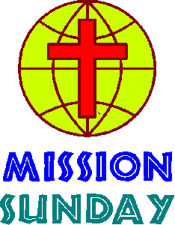 & 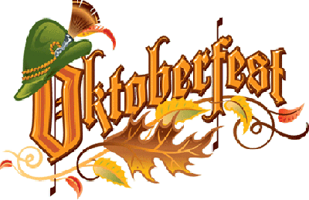

Mission-fest - Oktoberfest Luncheon
Sunday, October 25, 2015
12-3pm immediately following worship.
This special event includes bratwursts, a pot luck lunch, activities for the kids, and a special missionary presentation from Pastor Larry Rockemann.
Calling All Chef's

In need of your specialty sides to go with our brats, dogs and of course the "beer." If you are planning to attend, we simply ask that you bring a side dish or dessert to share, or perhaps you would like to contribute towards the underwriting of either the bratwursts or beer. We are especially looking for your best German potato salad, red cabbage or anything else you may want to share. Children will be entertained by our older youth and adults in the grass area across from the church during Pastor Rockemann's presentation. After the presentation, everyone will gather together for our Oktoberfest Luncheon. Any questions may be addressed to;

Elsa Webb (718) 727 9889
Brigitte Hermann (718) 720 6184

