COMMEMORATIVE CHRISTMAS TREE LIGHTS 2022
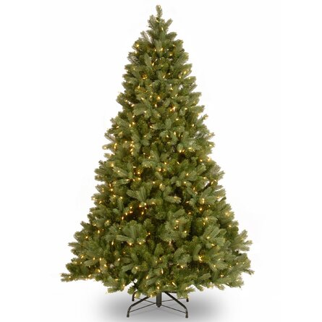
Once again, we will commemorate the Christmas Tree Lights. The cost is $2 per name. If you are giving a check, please make it out to St. John’s Lutheran Church (Memo – Commemorative Christmas Lights) You may either place your order form in the offering box or drop it off at the church office.

** All orders must be received no later than Sunday, December 4. **

Unless indicated as commemorating something, all names will be considered to be memorials. Additional names may be added on back. Also, please remember to include the names of those giving the memorial.

Name: Given by:

_________________________________________________________ ___________________________________________

_________________________________________________________ ___________________________________________

_________________________________________________________ ___________________________________________

_________________________________________________________ ___________________________________________

_________________________________________________________ ___________________________________________

_________________________________________________________ ___________________________________________

_________________________________________________________ ___________________________________________

Number of names ______________ x $2 = __________ amount enclosed

