St. John’s Lutheran Church
Proudly Presents
A Festival of Nine Lessons and Carols

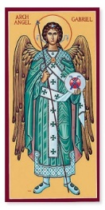Come share in this special recalling
of the Christmas Story through Scripture lessons and carols. Music of the season by our Adult ChoirAccompanied by
Hand-bells, Violin, Flute, Sax, Piano and Organ.

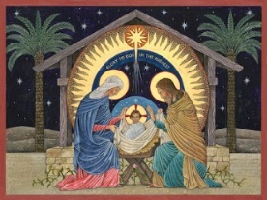

Sunday, December 16, 2018 at the
10:30 a.m. Divine Service

Also in attendance will be our
District President/Bishop Rev. Derek G. Lecakes

216 Jewett Ave, (718) 761 1600

www.stjohnslutheransi.org

