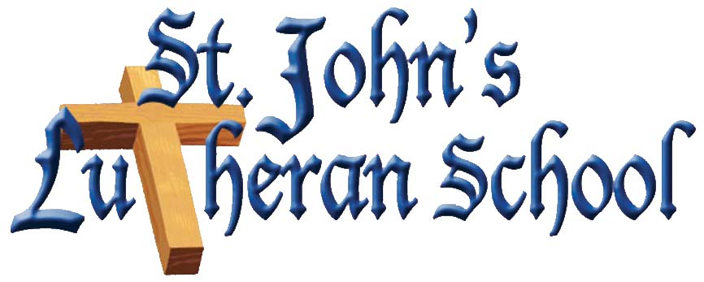

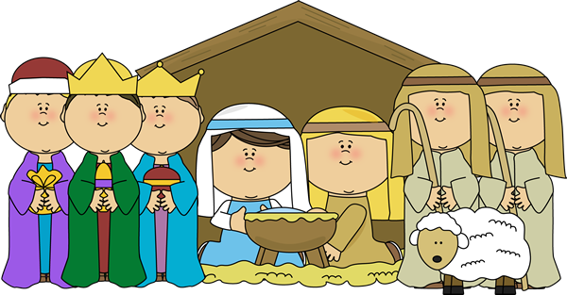
Please join us for our Second Annual Living Nativity (with live animals) on Friday, December 9, 2016 starting promptly at 7:00pm. Location; the school’s playground located on Reon Ave. across the street from school at 663 Manor Rd. See and hear our school and church children as they tell the story and act out and sing about our Savior’s birth. This a public event open to everyone.

